Final

# 1

1. CMMI is supposed to guide the improvement of the organization’s processes and its management and development ability as well as support the services and products (software in this case). The maturity of a software company means its ability to define, practice, and continually improve on different processes. As a software company does those things, it moves up the scale of maturity.
2. In CMM Level 2, there are 6 key processes that an organization must master:
   1. Requirements management
   2. Software project tracking and oversight
   3. Software quality assurance
   4. Software project planning
   5. Subcontract management
   6. Software configuration management

An organization at level 2 has mastered these key project management-related processes and is expected to be able to repeat its success with given a similar project. In CMM Level 3, an organization needs to master 7 more key processes:

1. Organization process focus
2. Training program
3. Software product engineering
4. Peer reviews
5. Organization process definition
6. Integrated software management
7. Intergroup coordination

An organization at level 3 has mastered the major processes related to construction of software along with additional project management-related processes.

# 2

1. The Agile manifesto addresses changeability. Agile addresses this characteristic because it prefers to respond to changes more than it prefers following a plan. One of the things Agile methods are built based on is the fact that there will be changes in the environment of the software project
2. The product backlog: an ordered list of all the remaining requirements or user stories for a product. The product owner will prioritize and order the requirements. Everybody can see what still needs to be done overall (developers will mostly focus on the sprint backlog). Sprint backlog: ordered list of tasks that need to be done for the current sprint. Tasks are broken down to be smaller (chunked) (usually 4 to 16 hours). The purpose of this is making it easier for the developers to know exactly what to do. Developers choose their next task based on the sprint backlog and their particular skills instead of being assigned tasks. An example would be assigning the GUI to one developer, the UI class to another, the control class to another, data manager to another, and the SQL database to another, while one person handles customer relations.

# 3

1. Actor of the system: waiter/waitress, chef, cashier, customer. They are the ones physically being and either working or interacting in the restaurant.

Non-actor stakeholder: owner of the restaurant and investors if it has.

1. My choice would be interview elicitation to get feedback from the actors (chef, waiter/waitress, customers, and cashiers) as they would be the ones who know what the system will need to get write down in the requirements. For example, I would ask the chef how they would want the orders of to appear on the screen or ask the waiters and waitresses how they would like to input the orders in the system and get feedback on that system
2. 1. User interface: they actors need to comfortable with the interface because they will be the ones using it most often.

2. Data format: for example, when ordering, a customer would like to know what an order look like

3. Individual functionality

4. System with different interfaces

5. Other constraints:

6. Business flow:

# 4

1. iPads will be used to take and display orders. They will also be used by the cashier.

Server for database.

1. Ipads: take orders by waiters from customers and view existing orders. Mainly done by cooks.  
   Server: store customer and order information and workers information maybe track points as customer gifts.
2. 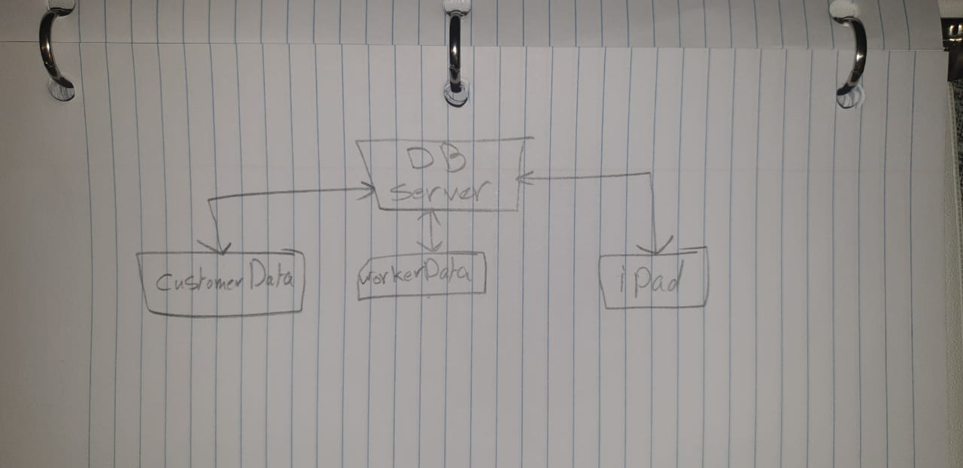
3. Business flow was the last requirement. They would need to upgrade for that requirement to do better. Ipad will be used to take and view orders.

# 5

# 6

Yes. The user can use the view classes to get data from the record and the control classes to change alter a record.

# 7

1. What we did is we had a UI layer at the top, then a Control layer underneath it. We then had a DataManager layer and finally at the bottom we had Objects layer.
2. We used close layered system. Our UI classes are only allowed to use the services of their corresponding Control classes and our Control classes are only allowed to use the services of the DataManager and the DataManager is only allowed to use the services of the Object class
3. Our system has a major advantage when it comes to modifiability and security because not any class would be able to change what the object classes have

# 8

1. 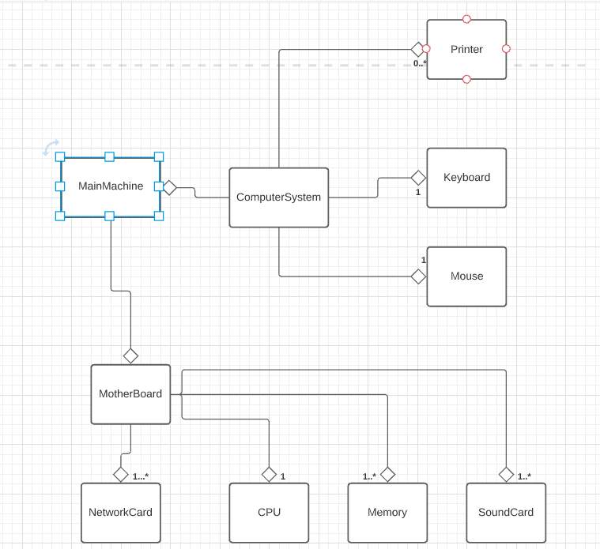
2. Chart, diagram

   Description automatically generated

# 9

# 10

1. Diagram

   Description automatically generated
2. 3. Because E-n+2P = 3, number of closed circuits+1 = 3 and binary decision +1 = 3
3. n < 10, n = 10, 10 < n < 20, n = 20, 20 < n < 30, n = 30, n > 30